|  |  |
| --- | --- |
| 2019 – 06 June | Lion’s Tales  *Newsletter of the Cedar Rapids Noon Lions Club of Cedar Rapids, Iowa* |
| **Officers:**  President: Kristin Glockhoff  1st VP: Mark Stewart  2nd VP: Scott Lindsley  Secretary: Mary Doyle  Treasurer: Don Magee  2019: Margaret Debner  Ron Mustaine  2020: Walt Hartman  Dean Thomas  2021: Dennis Egel  Gary Glockhoff  Membership: Terry Durham  Lion Tamer: Bill Severa  Tail Twister: Ron Mustaine  Past President: Greg Reed  **COMMITTEE CHAIRS:**  Program: Greg Reed  KidSight: Barb Taylor  Mary Ann Dawson  Vision: Scott Lindsley  Rich Rheinschmidt  Hearing: Bill Jurgensen  John Swenson  Pat Gourley (hearing aids)  Wright School: Margaret Debner  Linda Fisher  Diabetes: Margaret Debner  Hunger: Walt Hartman  Dean Thomas  Environment: Ron Mustaine  Childhood Cancer: Dennis Egel  Gary Glockhoff  School Outreach: Mark Stewart  Variety Show: Jan Federer  100-Yrs: Terry Durham  Gary Glockhoff | President’s Message: This time last year I was looking forward to being installed as our club’s president and thinking ahead to the coming year. What would the year bring in the life of our club? Now, looking backward, here’s part of what we’ve accomplished:   * **July** – Implemented new club structure geared toward the global service framework with board chairs for each of the service areas (Childhood Cancer, Diabetes, Environment, Hunger, Vision) * **August** – Mark Stewart started developing the School Outreach Program * **September** – Lions Variety Show raised $6,256 * **October** – Hosted District 9EC Fall Rally; shared cost with Urbana Lions to build a wheel chair ramp * **November** – Debuted redesigned Lion’s Tales newsletter and new club website * **December** – Participated in the Festival of Trees; Salvation Army Bell Ringing * **January** – Started new alternate menu options; funded two Premier Chamber Orchestra scholarships * **February** – Delivered Valentines to the Stead Family Children’s Hospital * **March** – Raised $3,125 through our non-event fundraiser * **April** – Banquet honored award winners Lion of the Year (Don Magee), Melvin Jones (Kristin Glockhoff), and Warren Coleman (Mary Doyle, Jan Federer, Bill Jurgenson) * **May** – Wright School carnival; presented $2520 donation to school & teachers * **June** – Will participate in Meals from the Heartland event, Camp Courageous Cleanup, and host the hospitality room at Iowa Lions State Convention   It has truly been my honor and privilege to serve as your president these past 12 months! Thank you for your volunteerism, your patience, your kindness to me throughout this year.    In service,  Kristin *“Summer is not obligatory. We can start an infernally hard jigsaw puzzle in June with the knowledge that, if there are enough rainy days, we may just finish it by Labor Day, but if not, there's no harm, no penalty. We may have better things to do.”* *~Nancy Gibbs* |
| **Program Chairs**:  August: Russell/Higdon  September: Glockhoff’s  October: Ralph Wasik  November: Glockhoff’s  December: Hartman / Reed  January: Reed / Hartman  February: Al Huneke  March: Jeff Busbee  April: Jan Federer  May: Dennis Egel  June: Gary Lindsey  July: Taylor/Dawson  **Greeters**:  August: Glockhoff’s  September: Siebenmann  October: MaryAnn Dawson  November: Bill Jurgensen  December: Walt Hartman  January: Mark Stewart  February: Barb Taylor  March: Al Huneke  April: Terry Durham  May: Charlie Gallaher  June: Jan Federer  July: Dennis Egel  **Tail Twisters**:  August: John Swenson  September: Dean Thomas  October: Greg Reed  November: Gary Glockhoff  December: Jan Federer  January: Ron Mustaine  February: Ralph Wasik  March: Elaine Brown  April: Dennis Egel  May: Walt Hartman  June: Taylor / Dawson  July: Elaine Brown | June Programs – Gary Lindsey  |  |  | | --- | --- | | 06 | Chad Hammar, Gems of Hope | | 13 | Adam Sullivan, CR Gazette, Topic: Drug Policy Reform in Iowa | | 20 | Thomas Hand, Southern College of Optometry, SVOSH | | 27 | Robb Hogg, Iowa State Senator from the 33rd District |  Barb Taylor and Mary Ann Dawson – you are on tap as our July program chairs ☺June Greeter – Jan Federer **Instructions:** A greeter signs up for one month and makes guests feel welcome.   * **Arrive by 11:45** and **wait to get your food**. * **Welcome visitors and make introductions** to the president and other officers. * **Find them a seat** by another welcoming member. * Supply each visitor with a laminated **visitor meeting agenda sheet** so they have the words to the first & fourth verses of the song. * Provide visitors with a **club brochure**, if available.   Thanks for helping grow the club!  **Dennis Egel – your smile will greet us in July ☺**  **June Tail Twisters: Barb Taylor / Mary Ann Dawson**  **Elaine Brown – what will you quiz us on in July?**  **June Birthdays:**   |  |  | | --- | --- | | 05 | Bill Kilbourn | | 24 | Ken Benson | | 25 | Barbara Taylor | | 27 | Bill Jurgensen |   **New Members:**  *See your name in print as the sponsor of a new member. Have you passed out any Lions Club business cards lately?* |

**Wright School Carnival**

It was a dark and stormy night… but a good time was had by all!

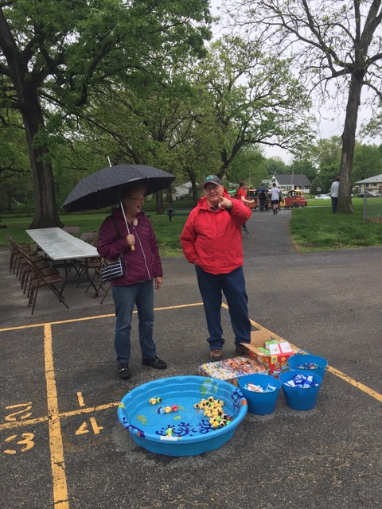 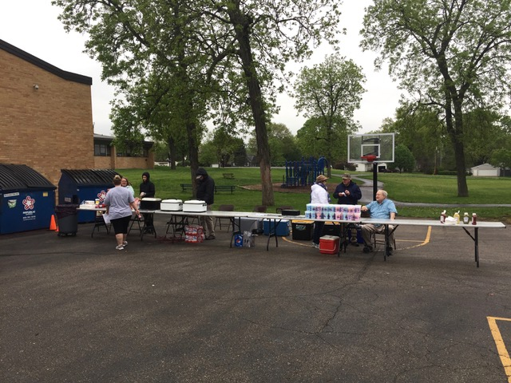

Mark Stewart and Jan Federer running the fish tank…

Gary Lindsey, Kristin Glockhoff, Bill Jurgensen and Ralph Wasik selling pizza, hot dogs, pop…

 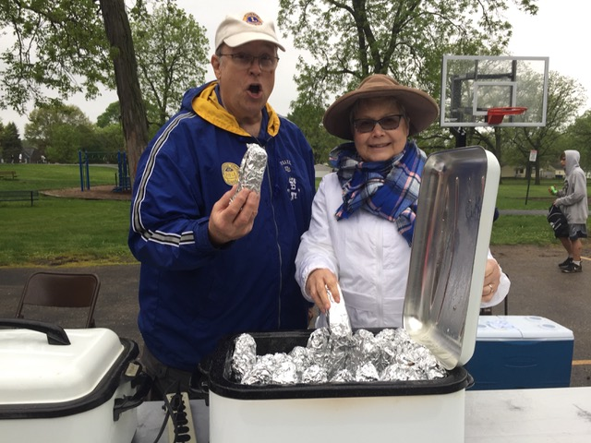

Kristin, Bill and Ralph selling cotton candy… See Kristin wrapped in warmth and Ralph without a coat… Note: Ralph’s son arrived shortly after this with his coat and hat…

Hot dogs, anyone? Couldn’t beat the $1.00 price! Scott Lindsley was across the way running the ring toss game, but he had so many winners he ran out of liters of pop before Gary could grab his picture! Ken Benson was also at the carnival, handing out work assignments and getting things set up for games, etc.

**From our Hunger Committee Chair, Walt Hartman**

**Project: Meals from the Heartland**



The Cedar Rapids Noon Lions Club has a history of helping those in need. We have contributed our labor, money, food and other assistance after disasters and in ordinary times. The Hunger Committee plus many of our club members have contributed the following:

* Arranged for eight Lion “bell ringers” to provide a total of 16 hours of their time to raise funds for the Salvation Army Kettle Drive.
* Arranged a program presented by the manager of “Meals from the Heartland” on January 17, 2019.
* Arranged for our Board to make a $300 contribution to the food bank at HACAP.
* Arranged for our Board to make a $200 contribution to the food bank at the Freedom Foundation veterans’ organization.

The committee is also in the process of organizing our members to participate in the “Meals from the Heartland” Fight against Hunger. This will be a meal-packing activity on June 14-15 in Cedar Rapids. We will be packing meals that will be provided to the needy in our area and around the world.

Don’t miss your opportunity to sign up for the 10:00 AM or the 1:00 PM shift on Friday, June 14, at the Double Tree Convention Complex. You may sign up for both shifts if you choose. Just put the following in your browser: *Meals from the Heartland Cedar Rapids* to go to the website to register or contact Walt Hartman at 319-396-5036 or hartmanwc@gmail.com.

**District 9EC Camp Courageous Service Experience**

**Saturday June 1st 2019 from 9:00 A.M. to 3:00 P.M**.

Come prepared to Clean, Paint, Fix, and in general do the best you can. Be dressed for whatever the weather is to be. Bring a pair of work Gloves. There will be a break for lunch at camp. You all know that the food at camp is always good! Cost is $6.00. We will need an approximate number of workers, about a week before. We will have a sign-up sheet at the May meetings, or let Gary Glockhoff know if you want to volunteer that day.

**Lions Youth Exchange Program**

Youth Exchange Program is still looking for host families for international students. This year’s students will be here on June 29th, 2019 and will be leaving July 27th, 2019.  Camp is July 14 - July 21, 2019. If interested in hosting, please let Kristin Glockhoff know.

**Lions Club Student Advisory Board**

Due to snow days and testing days, we were able to host only two school visits this year. The Board of Directors did vote to continue this program next school year. Stay tuned!

**From our Diabetes Chair, Margaret Debner**

**DIABETES UPDATE: HEAVILY PROCESSED FOODS CAN MAKE US HEAVY**

Twenty healthy volunteers served as “diet monkeys” to help understand the role of processing in our foods. For 2 weeks they ate ultra-processed foods and for 2 weeks they ate unprocessed food.

The trail compared calories consumption, weight gain or loss. Each type of menu had the same number of calories, fat, sugar, carbs, and salt. The diners said they were equally satisfied with both.

Let’s compare the results:

Unprocessed Processed

Ate slower wolfed it down

Ate smaller amounts consumed 508 more calories

Lost 2 pounds gained 2 pounds

High in texture Smooth and easy to eat

More variety Much less variety offered

Fewer additives Numerous additives

Smaller servings Large portions

So it is not just about sugars and fats, there is something else going on that leads to the 40% obesity rate for adults and 3x more overweight children. It is how the food is processed and the choices we make both for meals and snacks.

What is ultra-processed food? It is far from the original item. For example: chicken when left unprocessed is the meat without all the added chemicals and breading that is baked or broiled not fried. Ultra-processed has more additives, may be ground, pureed, formed, extruded, spiced up, colored, breaded, and then deep fried.

Most frozen or shelf-stable entrees are ultra-processed. The food value has dropped and the calories have been increased. Snacks are a big factor since they are often deep-fried, overly salted, have added flavors, contain additives, are easy to consume in large quantities, readily available and so tasty.

Unprocessed foods are in their natural state with only the nonedible parts removed. A 6”carrot a al natural has about 30 calories, vitamin A, C, carotene and fiber. A ½ cup frozen, candied carrot serving contains about 120 calories, added sugar, salt, high fructose corn syrup, and ingredients you can’t pronounce. Plus it will take you

longer to eat the raw carrot thus lower your calorie intake and increase your feeling of fullness.

This study was published in the *Cell Metabolism* journal and featured in the Gazette on 5/19/19

Other studies conducted by several institutions point to the problem of belly fat quite possibly being a result of processed foods and over consumption of carbohydrates and additives. Some of the main contributors are soft drinks, juices, candy, salad dressings and dips, pizza, deep-fried foods, and ready to eat entrees such as frozen dinners, cold meat, sugared or overly salted foods, and sweetened dairy products.

So what are some choices?

Unprocessed Processed

Roasted nuts & berries Salted, deep fried, dehydrated, infused

Fresh fruits, veggies Canned, dehydrated, flavor enhanced, added salt or sugar

Meat, fresh, no additives Marinated, salted, barbecued, flavor or broth added, cold cuts, fatty, extruded

Breads & Cereals White, 9 grain, sweet

100% whole wheat Check the label for added flavors, color, enriched, and fats

You are what you eat. A skinny carrot or lean meat will make you healthier and look less like the donut that is so tempting. This can be the road to good health and may be your largest challenge ever!

**REMINDERS:**

**Amazon Smile**

Do you order things from Amazon? If so, you could be contributing to the Cedar Rapids Noon Lions Club through the Amazon Smile program! Amazon donates 0.5% of the price of your eligible AmazonSmile purchases to the charitable organization of your choice. The next time you order from Amazon, go through Amazon Smile.

* Log on to <https://smile.amazon.com>
* Select your charity 
* Place your order!

**Volunteer for a Lions Club Committee**

What do you enjoy doing? What are your interests? Lions Club probably has a committee where your talents will shine!

|  |  |  |
| --- | --- | --- |
| * Childhood Cancer | * Vision | * Marketing |
| * Diabetes | * KidSight | * Membership |
| * Environment | * Wright School | * Variety Show (Sept 2019) |
| * Hearing | * High School Outreach | * 100 Year Celebration (June 2020) |
| * Hunger | * Fundraising | * Tech (Website, Facebook) |

Please volunteer to help with a Lions committee that speaks to your heart for service. If you haven’t had a chance to sign up at a Lions Club meeting, e-mail President Kristin ([k.glockhoff@gmail.com](mailto:k.glockhoff@gmail.com)) with your committee of choice. Thank you!!

**Events Calendar:**

# *Board Meeting Schedule = 3rd Thursday of each month at 10:30AM*

* **01 June 2019 – Camp Courageous Work Day 9am-3pm**
* 01 June 2019 – Helen Keller Day
* 05 June 2019 – World Environment Day
* 06 June 2019 - National Hunger Awareness Day
* 07 June 2019 – Lions Clubs International Birthday
* **07-08 June 2019 - State Convention - Host Hospitality Rooms**
* **14-15 June 2019 – Meals from the Heartland event**
* 05-09 July 2019 – 102nd International Convention (Milan, Italy)
* **08 September 2019 – Lions Variety Show at CSPS**
* **06 May 2020 – 100th ANNIVERSARY OF CEDAR RAPIDS NOON LIONS CLUB**
* **13 June 2020 – 100th Anniversary Party!**

**MINUTES-CEDAR RAPIDS NOON LIONS BOARD**

**May 16, 2019 10:30 am Longbranch Convention Center**

**Attendance:** Kristin Glockhoff, Mark Stewart, Scott Lindsley, Mary Doyle, Don Magee, Ron Mustaine, Walt Hartman, Dean Thomas, Gary Glockhoff, Dennis Egel

Committee Chairs: Bill Jurgensen, Scott Lindsley, Barb Taylor

PDG: Terry Durham

**Call to order** by President K Glockhoff, 10:30 am

**Agenda approved:** approved

**Minutes approved:** motion D Magee, second E Egel, carried

**Financial Reports:** Balances on hand are: Administrative account, $7,810.81; Charity account: $1,573.86; Total Memorial Fund account, $48,139.85; Balance of all accounts $57,524.52. Motion to approve T Durham, second D Thomas, carried.

**Correspondence:** K Glockhoff shared a note from the wife of member Gary King. Gary has appreciated the get well cards he has received from members.

**STANDING COMMITTEE REPORTS:**

**Membership:** T Durham, chair: Our new members will be inducted soon.  The board reviewed a list of recently dropped members looking for people who might be invited to rejoin the club.

**Vision:**  S Lindsley, co-chair: Vision screenings & fittings in April: 2 Lions @ 13 hours served 9 adults. Funds donated $45, YTD $855

**Hearing:** B Jurgensen, co- chair: No applications to report at this time. 30 hearing aids are being prepared to send to the hearing bank.

**KidSight:** B Taylor, co-chair: KidSight screening in April:8 Lions @ 10.5 hours screened 8 children. YTD 2352 children screened, Referrals 132

**Wright School partnership:** M Debner, co-chair: School Club partnership in April: 4 Lions @ 18 hours reported working with 75 students tutoring. 10 volunteers have signed up to help with the Wright School Carnival, April 17.

**Hunger:** W Hartman: Volunteers are requested to sign up for the Meals from the Heartland event June 14. Registration is online. June is National Hunger month.  A motion was made to donate club funds to HACAP, $300 and Freedom Foundation (veterans food bank), $200. Motion M Stewart, second R Mustaine, carried.

**Environment:** R Mustaine: An environmental handout was passed out at the noon meeting.

**OTHER COMMITTEE REPORTS:** M Stewart was applauded for his efforts to bring high school students to our noon meetings. The board agreed to invite high school students to noon meetings again next year.

**OLD BUSINESS:**

**100 Year Celebration;** G Glockhoff and T Durham reported on plans for the 100 Year Celebration.  The original celebration date, May 23, 2020 coincides with Memorial Day. A new date will be selected to be held at Elmcrest Country Club.  The possibility of a Hickory Golf Tournament is being explored. The club hopes to locate 4-5 Lions benches around the city in honor of the 100 Year Anniversary. The committee members continue to work with the Parks Director on this project.

**LVS:** September 8, 2019 is the tentative date for the Lions Variety Show at CSPS.  Mike Maas has committed to play again. Larry Thorson is helping the committee find a comedian for the show.  Sponsors will be needed.

**District 9EC Camp Courageous Work Day June 1; (9-3pm):** 3 volunteers from the club are needed for this clean up event.

**NEW BUSINESS:**

**State Convention Hospitality Room Friday June 2/Saturday June 3 (8-11)pm:** 6 club members have volunteered to serve as hosts in the hospitality room.

**Grant request for new camera or repair of existing camera:** J Facion and K Glockhoff are working on a grant application to repair an existing KidSight camera or to purchase a new one.

Adjourned at 11:30 am

Respectfully submitted,

Mary Doyle, Secretary

**Web Addresses**

**Lions International** [**www.lionsclubs*.org***](http://www.lionsclubs/)

**Iowa Lions Website** [**www.iowalions.org**](http://www.iowalions/)

**Iowa Lions Newsletter** [***www.iowalions.org/theiowalion.html***](http://www.iowalions.org/theiowalion.html)

**District 9EC** [**www.iowalions*9ec.org***](http://www.iowalions/9ec.org)

**Cedar Rapids Noon Lions Club…………https://www.cedarrapidsnoonlionsclub.com**

**Amazon Smile…………………………………………………**[**https://smile.amazon.com/**](https://smile.amazon.com/)

*Supporting:* ***Cedar Rapids Thursday Noon Lions Charities Inc***

**From K.A. Nanjappa**

**\*WELCOME TO THE 21ST CENTURY!\***

|  |  |
| --- | --- |
| Our phones = | Wireless |
| Cooking = | Fireless |
| Cars = | Keyless |
| Food = | Fatless |
| Tires = | Tubeless |
| Tools = | Cordless |
| Dress = | Sleeveless |
| Youth = | Jobless |
| Leaders | Shameless |
| Relationships = | Meaningless |
| Attitude = | Careless |
| Wives = | Fearless |
| Babies = | Fatherless |
| Feelings = | Heartless |
| Education = | Valueless |
| Children = | Mannerless |
| Government = | Useless |
| Parliament = | Clueless |
| Masses = | Helpless |

Everything is becoming LESS but still our hope in God is = Endless.

In fact I am Speechless because Salvation remains = Priceless!!