|  |  |
| --- | --- |
| 2020 – 09 September | Lion’s Tales  *Newsletter of the Cedar Rapids Noon Lions Club of Cedar Rapids, Iowa* |
| **Officers:**  President: Scott Lindsley  1st VP: John Swenson  2nd VP: James Russell  Secretary: Mary Doyle  Treasurer: Don Magee  2020: Dennis Egel  Gary Glockhoff  2021: Greg Reed  Rich Rheinschmidt  2022: Mark Stewart  Walt Hartman  Membership: Terry Durham  Lion Tamer: Bill Severa  Tail Twister: Ron Mustaine  Past President: Mark Stewart  **COMMITTEE CHAIRS:**  Program/LCIF: Mark Stewart  KidSight: Barb Taylor  Mary Ann Dawson  Vision: Scott Lindsley  Rich Rheinschmidt  Hearing: Bill Jurgensen  John Swenson  Wright School: Margaret Debner  Diabetes: Margaret Debner  Hunger: Walt Hartman  Environment: Ron Mustaine  Childhood Cancer: Dennis Egel  School Outreach: Mark Stewart  Variety Show: Jan Federer  100-Yrs: Terry Durham  Gary Glockhoff | President’s Message: On Thursday, August 13 at noon, I was sitting at a picnic table next to the Noelridge duck pond waiting for any Lions who might not have received the meeting cancellation notice for that day. Fortunately, given all the storm debris hindering travel, no one showed up. After spending long hours clearing limbs and brush the previous two days, sitting there gave me time to pause and wonder how CR Noon Lions would emerge from this latest challenge and what would be our next steps to move forward. Admittedly, I felt like I was living in a fog so there were no immediate answers that came to mind. However, a week later I received a call from Terry Durham and the Lions commitment to community began to surface once again.  Terry explained that our District Governor, Stan Stanfield, wanted to meet to discuss a LCIF Disaster Relief Grant with representatives from the 9EC District. In the meeting that followed it was decided that a $10,000 LCIF Disaster Relief Grant would be given to support the residents of Linn County. It was determined that our club would work with the HACAP Food Reservoir to purchase food supplies that would ultimately go to the many food distribution locations in the Linn County area. On August 25 the grant was used to pay for an order submitted to a wholesaler in Minnesota for pallets of food such as canned peaches and peanut butter. In addition, $6,000 of Care and Share funding was allocated to other counties in the district affected by the storm.  Club initiatives that are starting to evolve include a virtual fundraising event and potential activity with Iowa KidSight. At our recent board meeting, Jan Federer and Mary Doyle discussed the possibility of having a virtual variety show to replace the annual variety show that was canceled this year. Barb Taylor said there has been some communication regarding screening for preschool children in programs that aren’t connected to a school system. Barb will be evaluating the potential and determining safe protocols for all involved in the screening process.  Another fundraising initiative with excellent potential is selling raffle tickets at Prospect Meadows. Mark Stewart said tournaments will be going into November and he will be working with the organizers to plan a weekend Lions could be involved.  A huge shout-out to Al Huneke for helping us reconnect in the midst of the off and on internet communication issues. The board was able to complete a full meeting on Aug 27 and there were approximately 18 in attendance. I anticipate our next Zoom club meeting will also go well on Thursday, September 10.  So yes, while it’s clear we are all living in a “recovery phase” accompanied by some fatigue, the Lions commitment to community service is always present and evolving regardless of the circumstances. – Scott Lindsley    Scott Lindsley  President, CR Noon Lions Club |
| **Program Chairs**:  August: Mark Stewart  September:Terry Durham  October: OPEN  November:Jan Federer  December:OPEN  January: Mark Stewart  February: OPEN  March: OPEN  April: OPEN  May: OPEN  June: OPEN  July: OPEN  **Greeters**:  August:  September:  October:  November:  December:  January:  February:  March:  April:  May:  June:  July:  **Tail Twisters**:  August:  September:Gary Glockhoff  October:  November:  December:  January:  February:  March:  April:  May:  June:  July: | September Programs – Terry Durham  |  |  | | --- | --- | | 10 oe | Zoom Meeting – Rick Bachmann LCIF | |  |  | | 24 | Mohawk park pavillion – | |  |  |   Months marked “OPEN” are opportunities for you to be the program chair for that month. Contact Mark Stewart at [mesbigfish@yahoo.com](mailto:mesbigfish@yahoo.com) to volunteer. September Greeter – will resume when lunch meetings resume **Instructions:** A greeter signs up for one month and makes visitors feel welcome.   * **Arrive by 11:45** and **wait to get your food**. * Make sure to **welcome any visitor and make introductions** to the president and other officers. * **Find them a seat** by another welcoming member. * Supply each visitor with a laminated **visitor meeting agenda sheet** so they have the words to the first & fourth verses of the song. * Provide visitors with a **club brochure**, if available.   Thanks for helping grow the club!  **September Tail Twister: Gary Glockhoff**  The tailtwisting job is one quarter as hard as it has been in the past! And we are asking for paper money donations and fines as our coffers are diminished by not having regular meetings. Please sign up with an email to Ron Mustaine.  **September Birthdays:**  26 Aaron Horn |

**Lion of the Year**

I was surprised Tuesday afternoon when Don Magee called and said he wanted to bring something to me. He arrived about 20 minutes later and placed a square box on the front porch. We maintained our social distance and he told me to open the box. To my surprise, it was the Lion of the Year Award.

This was totally unexpected and I feel very humble in receiving the award. There are many deserving members in our club who qualify yearly for this award. I don't think we join Lions to receive awards, but rather to serve the community in which we live. Yet such an acknowledgement is appreciated. I want to thank the awards committee for this honor and will proudly display the Lion's Club lion in my home. Thank you, fellow Lions.

Dennis Egel

**Eyeglass Collection**

If you are comfortable with picking up glasses, you might give your collection location a call and see if they need a pickup.

**100 Year Celebration**

The celebration has been postponed to 2021. We will try to reschedule a date near to the time of the 1921 charter night. Let’s hope the Covid-19 thing is over by then.

**Duracho Help**

9EC District Govenor Stan Stanfield has requested and received a $10,000 emergency grant from LCIF and the Lions share is going to help people in the Cedar Rapids area. The district increased the effort with $6000 from the Care and Share account and added $3000 from an impact grant from LCIF for a total of $ 19,000. Relief projects will happen in Mt. Vernon, Stanwood, Clarence, Clinton and other towns along the Hwy 30 corridor. Members of CR Noon will be helping distribute food we purchased through HACAP.

**2021 USA/Canada Forum**

I’m sending out this newsletter by email to all of you so that you can sign up for the USA/Canada Leadership Forum. Because of Covid, it’s a virtual event this year so you don’t have to travel or stay in a hotel. You can just start up your computer and log in. Kristin and I have been to 6 or 7 forums and they are really awesome. Next year you will want to sign up for the forum as it will be in Des Moines, but this year you can attend from your home.

“Racing into the Future with Diversity and Kindness” is the theme of the forum this year. There will be 20 virtual seminars: two hours on Friday evening, three hours during midday on Saturday and two hours on Sunday afternoon. Subject matter includes: Childhood Cancer, Faces of Diabetes Innovation, how to approach the younger generation about Lions, projects for women and families, learning more with NAMI and many more. Registration is $20. Go to lionsforum.org with credit card in hand.

You will get a taste of the high caliber of thinking that goes into this forum and will definitely want to go to Des Moines. The last program is put on by our own Jerry Inman who is chairman of the host committee.

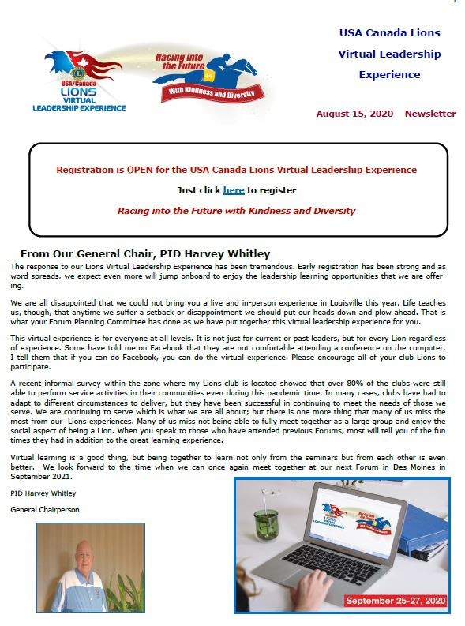

**MINUTES – Cedar Rapids Noon Lions Club Board**

August 27, 2020 10:30 am

Zoom meeting

**Attendance:**

Officers: Scott Lindsley, John Swenson, Mary Doyle, Don Magee, Dennis Egel, Gary Glockhoff, Greg Reed, Rich Rheinschmidt, Walt Hartman, Mark Stewart

Committee Chairs: Terry Durham, Barb Taylor, Mary Ann Dawson, Dennis Egel, Greg Reed, Ron Mustaine, Scott Lindsley, Rich Rheinschmidt, Gary Glockhoff, Kristin Glockhoff

PDG: Terry Durham

Past President: Mark Stewart

**Call to order** by Scott Lindsley, 10:30 am

**Agenda approved:** motion J Federer, W Hartman second, carried

**Minutes approved:** motion G Reed, B Taylor second, carried

**Financial Reports:** Balances on hand are: Administrative account, $6,381.71; Charity account: $515: Total Memorial Fund account, $52,161.54; Balance of all accounts, $59,058.25. Motion to approve G Reed, second B Taylor, carried. The Quarterly Audited Financial Report ending March 30 and June 30, 2020 was accepted and placed on file. Motion to approve M Stewart, 2nd S Lindsley, carried

**Correspondence:** S Lindsley shared information regarding Lions Peace poster contest. The club no longer participates due to lack of interest from local schools.

**STANDING COMMITTEE REPORTS**:

**Membership**: T Durham: Nothing to report

**KidSight:** B Taylor, M Dawson co-chairs: B Taylor recommends that the club should delay KidSight screenings until January. In the meantime, KidSight has been receiving requests from HACAP groups. It was decided that working with small preschool groups could be a test of how to proceed with KidSight screening. Barb will be evaluating the potential and determining safe protocols for all involved in the screening. She will be contacting volunteers.

**Wright School partnership**: no report

**Lions Variety Show:** Jan Federer reported that Linn Mar student, Tejas Gururaja,, has presented a proposal for organizing a virtual fundraising campaign for the Lions Variety Show. Tejas recently created a virtual fundraiser for the Madge Phillips Center and he would use a similar format. He is willing to put together a 45-minute virtual variety show which would be shared on various media platforms. Sponsors would then be asked to contribute as donors to the show. The scale of this fundraiser would be smaller than the live shows. The goal would be to raise $1,000-$2,000. Several members of the board expressed interest.

**100 Year Celebration:** The celebration has been postponed to 2021. We will try to reschedule a date near to the time of the 1921 charter night.

**SERVICE COMMITTEES:**

**Environment:** Ron Mustaine: nothing to report

**Hearing:** John Swenson: nothing to report

**Hunger:** Walt Hartman, Dean Thomas: *See Lions Clubs International Foundation grant*

**Vision:** Scott Lindsley, Rich Rheinschmidt: Activity has picked up. Vision screenings and fittings in July: 1 Lion donated 10 hours helping 6 clients. Funds donated $180.

**Diabetes:** no report

**Fundraising:** Greg Reed: Mark Stewart will look into a fundraising opportunity at Prospect Park.

**Childhood Cancer:** Dennis Egel, Gary Glockhoff: nothing to report

**Marketing, Website and Newsletter:** Kristin and Gary Glockhoff announced their plans to move to Des Moines in November. Kristin has been responsible for developing and maintaining our club website. Al Huneke has volunteered to take over website management. The club will need to find someone to take over writing and distributing the newsletter. Gary is willing to help remotely until another club member takes over.

***Kristin and Gary have been instrumental in creating and maintaining communication links for our club. We need volunteers to fill in these important roles.***

**OLD BUSINESS:**

**Lion of the Year**; Dennis Egel is our Lion of the Year 2019. Dennis has been club president twice and has served on several committees. Dennis said that he was pleased and humbled to receive the award, knowing that there were other members who were deserving of Lion of the Year. *Congratulations Dennis.*

**Club Format:** M Dawson made a suggestion for announcing Tail Twisting events and raising money for the administrative fund. She suggested posting the events in the newsletter and sending money to Don Magee (at his home address).

Club meetings will be the 2nd and 4th Thursday of the month at 12:00. Board meetings will be the 3rd Thursday of the month at 10:30. All meetings will be virtual unless otherwise announced.

**NEW BUSINESS**:

**2nd Vice-president.** Jim Russell was nominated for 2nd vice-president. Motion G Reed, second Gary Glockhoff, carried. *Congratulations and thank you, Jim*

**United Nations partnership:** Jan Federer presented a proposal for the club becoming a UN partner at $50 per year membership. The Lions International has a history of partnership with the United Nations. The board discussed the proposal but no action was taken.

**Lions Emergency Funds:** 9EC District requested and received a $10,000 emergency grant from LCIF and the Lions share is going to help people in the Cedar Rapids area. The district increased the effort with $6000 from the Care and Share account and added $3000 from an impact grant from LCIF for a total of $ 19,000. Relief projects will happen in Mt. Vernon, Stanwood, Clarence, Clinton and other towns along the Hwy 30 corridor. Members of CR Noon will be helping distribute food we purchased through HACAP. *****

Adjourned at 12:00 pm

Respectfully submitted,

Mary Doyle, Secretary

**Volunteer for a Lions Club Committee**

It’s never too late to volunteer for a Lions Club committee! What do you enjoy doing? What are your interests? Lions Club has a committee where your talents will shine!

|  |  |  |
| --- | --- | --- |
| CHILDHOOD CANCER   * Dennis Egel * | KIDSIGHT   * Barb Taylor * * Mary Ann Dawson * | TECH (Website, Facebook)   * Gary Lindsey (Facebook) * Kristin Glockhoff (Website) * Al Huneke (Dropbox) |
| DIABETES   * Margaret Debner * | WRIGHT SCHOOL   * Margaret Debner * | NEWSLETTER   * Gary Glockhoff * * Kristin Glockhoff |
| ENVIRONMENT   * Ron Mustaine * | HIGH SCHOOL OUTREACH   * Mark Stewart * | VARIETY SHOW (Sept 2021)   * Jan Federer * * K. Nanjappa * Mary Doyle * Elaine Brown * Dennis Egel * (Club President) |
| HEARING   * Bill Jurgensen * * John Swenson * Pat Gourley (hearing aids) | VISION   * Scott Lindsley * * Rich Rheinschmidt | FUNDRAISING   * Greg Reed * Julie Facion |
| HUNGER   * Walt Hartman * * Dean Thomas | MARKETING   * Gary Lindsey | 100 YEAR CELEBRATION (May 2021)   * Terry Durham * * Gary Glockhoff * Kristin Glockhoff * (Club President) |
|  | MEMBERSHIP & RETENTION   * Terry Durham *   All Club Members! |  |

Please volunteer to help with a Lions committee that speaks to your heart for service. If you haven’t had a chance to sign up at a Lions Club meeting, e-mail President Scott ([Lindsley.scott@gmail.com](mailto:Lindsley.scott@gmail.com)) with your committee of choice. Thank you!

**Web Addresses**

**Lions International** [**www.lionsclubs*.org***](http://www.lionsclubs/)

**Iowa Lions Website** [**www.iowalions.org**](http://www.iowalions/)

**Iowa Lions Newsletter** [***www.iowalions.org/theiowalion.html***](http://www.iowalions.org/theiowalion.html)

**District 9EC** [**www.iowalions*9ec.org***](http://www.iowalions/9ec.org)

**Cedar Rapids Noon Lions Club…………https://www.cedarrapidsnoonlionsclub.com**

**Amazon Smile…………………………………………………**[**https://smile.amazon.com/**](https://smile.amazon.com/)

*Supporting:* ***Cedar Rapids Thursday Noon Lions Charities Inc***

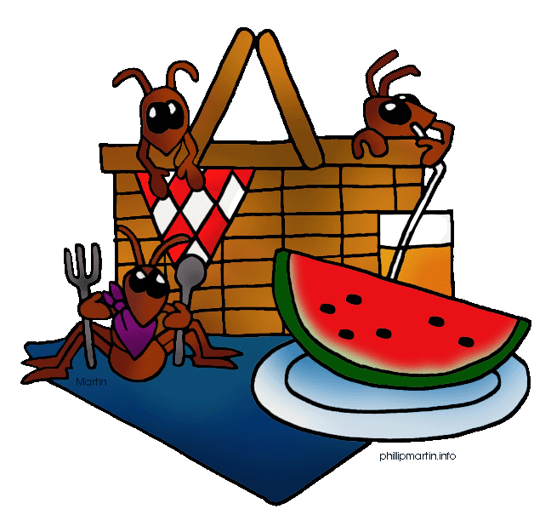

[This Photo](http://picnicwithants.com/2012/04/26/tag-line-hawmc-day-26/) by Unknown Author is licensed under [CC BY-NC](https://creativecommons.org/licenses/by-nc/3.0/)

Don’t forget our Thursday September 24th picnic at Mohawk park at noon. BYOF. (you can have your fill of all the food you bring yourself - Meredith Wilson)